Kellie Clinton
Dr. Whalen
DSCI401
12/01/2025
The Great Rescue Dog Show Final Project
Introduction
For my project, I will be comparing the American Kennel Club (AKC) dog popularity to shelter adoptions. I have always been a dog lover and watched the annual AKC National Championship on television to see what breed the judges will pick for that year. Then see if that breed shows up in our neighborhood walks.
The dataset AKC Dog Breed Featured Descriptions describes the characteristics of each breed such as their minimum and maximum height/weight, coat type, life expectancy, etc. Then the dataset ranks affection levels, kid friendliness, shedding, adaptability, playfulness, etc. on a scale 1 to 5. There are 195 unique purebred dogs on this list. This dataset gives an in-depth description of breed characteristics that people can use when deciding what dog would work best for their lifestyle.
Popularity is treated separately from breed characteristics. The dataset AKC Most Popular Dog Breeds shows AKC’s ranking of the breeds from 2013 – 2023. On this list the breeds are ranked from 1 as the best, to about 200 as the worst, each year. Not every breed has a ranking each year because each dog may not be AKC-registered yet, are not a recognized breed, or are disqualified for insufficient breed participants. I will look more into the trends of rankings later.
I pivoted longer on “Ranking.Year” in the dataset AKC Most Popular Dog Breeds so each year would be a row for each ranking. Thus, the breed and group would repeat each year the dog was ranked. If the dog was not ranked for a specific year, it would not show up.
The dataset Adoptable Pets is from the Sonoma County Animal Services website listing the animal shelter intake and outtake from 2012 to 2025. There are 31,703 animals listed on the dataset. I am only interested in dogs so I will filter out cats, birds, bunnies, etc. Filtering only dogs gives 17,855 rows. The dog breeds feature purebreds, mixes, and unknow breeds/mutt. Since AKC only looks at purebreds, I filtered the mutts out leaving a comparable 7,416 rows of purebred dogs.
Major Questions
The shelter can use this information to highlight the hard-to-adopt dogs to give them special support, such as a vet sign off and all shots to simplify ownership. This will increase the overall adoption rate.
Since people think of mutts as having a dominant breed, these comparisons between the AKC and a dog shelter are applicable to individuals’ consideration. This will reduce the return rate.
These are the questions I will dive into based on the combined datasets:
- Does AKC popularity influence adoptions?
- What is the turn around duration for adoption and what variables influence it? What are the favorable/unfavorable variables when adopting a dog?
- Do popular dogs ever come up for adoption? How quickly do they get adopted compared to less popular breeds?
- What variables are most impactful for sheltering euthanized dogs?
Analysis and Discussion
To answer the first question about whether AKC popularity influences adoptions, I selected the Adoptable Pets dataset where the breed was in the AKC Most Popular Dog Breeds. Then filtered to limit based on the adopted date range 2013 to 2023 to match the available AKC dates. By grouping by breed, outcome year, and AKC rank, I counted how many dogs were adopted per breed per year.
Based on figure 1, AKC ranking indicates an adoption pattern. For example, Chihuahua was the most adopted dog from 2014 – 2018. Chihuahua was the 24th (X axis) most popular with a count of 117 (the highest Y axis entry) adoptions.
To answer the second question about the turnaround for adoption, I left joined the AKC Dog Breed Featured Descriptions and Adoption Pets dataset on breed. Filtered to get 1,371 adopted dogs. Then I looked at the column Days in Shelter to see the average days in the shelter (46.18 days), median (25 days) and standard deviation (75.95 days), figure 2a. This gave characteristic variable options that can impact adoption.
Using the library plotly, Figure 2b shows an interactive histogram relating the count of dogs adopted to the days that they were in shelter. By hovering over the highest bar, the count of dogs shows that 643 dogs were adopted in 22.175 days. At the extreme maximum, there are 6 dogs that took over 750 days to get adopted. This will be discussed later.
Then I looked at each variable using a statistics summary model to see what may influence adoption, see figure 2c. The overall model has an F-value = 9.935, p-value < 2.2e-16, so we reject $H_{0}$ and conclude that we have a statistically significant linear relationship between days in shelter and all the other variables. The variables that are statistically significant when adopting a dog are size – puppy/small/toy; trainability category – eager to please; minimum weight; maximum weight; affection with family; good with young children; shedding level; intake type – confiscate/surrender/stray; intake condition – treatable/rehab; and outcome condition – pending.
To answer the third question about popular dogs that ever come up for adoption and adoption quickly, I left joined the AKC Most Popular Dog Breeds and Adoptable Pets datasets this time also on outcome year the dog was adopted compared to ranking year of breed. I only looked at adopted dogs during the years 2013-2023 to match the AKC Ranking years. Then I created popularity group categories based on the AKC ranking: Top 10, Ranking 11-50, and Ranking 51-200. This is an easy way to group the rankings. Figure 3a shows majority of dogs are in the Ranking 11-50 (696 dogs) compared to Top 10 (304 dogs) and Ranking 51-200 (202 dogs). On average, ranking 51-200 has the fastest turnaround time (33.84 days). For the median, Top 10 has the fastest turnaround time (21 days). Figure 3b shows the box plot of these group rankings.
The outliers in the Top 10 were very surprising to me because it took two dogs almost three years to get adopted. I was predicting that Top 10 would have the fastest turnaround in mean and median. Looking further into the outliers, I created an outlier dataset by finding the lower and upper bound then left joined by the popularity group. Figure 3c shows the outliers with their characteristics in Days in Shelter descending order. The first five dog’s intake types were confiscated with Field Services Cruelty/Neglect. Four of the dogs came to the shelter on 02/10/2018, probably from the same place. Identifying outliers is important for how the shelter supports these dogs to carry them and find adoption homes.
To answer the fourth question about what variables are most impactful for sheltering euthanized dogs, I used the Adoptable Pets dataset filtered on Outcome Type as Euthanize. Grouping on Outcome Subtype, I was able to summarize the Days in Shelter by mean, median, and count. Then I pivoted longer on mean and median days to graph the values as the y-axis and Outcome Subtype as the x-axis. Figure 4a shows the shelter trying to hold onto the dogs as long as they can, based on the mean. The older dogs (aged) were at the shelter on average 73.67 days while the aggressive dogs were there on average 28.88 days, all the way to the underage weight dogs which were there an average of 4 days. It seems that the dog’s health and behavior were key variables for euthanizing sheltered dogs. Behavioral issues caused faster euthanasia, so shelter expectations may be set accordingly.
Figure 4b shows the count of dogs by Intake Condition for Euthanasia Subtype. Similar to above, I grouped by Outcome Subtype and Intake Condition then summarized by counting the dogs. Manually, I put the Outcome Subtype graphs in order based on the overall count. The graph Aggressive shows most of the dogs came into the shelter with unknown (194 dogs) or untreatable (161 dogs) conditions. While the Aged graph shows that these dogs had unknown conditions (3 dogs). Overall, most of the euthanized dogs came in with unknown or untreatable conditions.
Conclusion
By analyzing these three datasets it shows that there needs to be a centralized dog breed portal that lists the universal dog breed with characteristics. The portal could be based on AKC documentation because it is publicly recognized. Then it is easier and faster for shelters to select a preset breed or multiple breeds option during intake. Similarly, the portal should list common universal code values used at intake. The objective being sharable data and intake simplicity across environments. By using the AKC breed popularity and behavioral characteristics, it will simplify how shelters advertise dogs in a consistent way that potential adopters can easily understand.
Euthanizing is a big shelter issue. By looking at the data, behavioral issues were the most common and fastest cause for euthanasia. Addressing behavioral issues and recognizing the limitations to modify these issues are important for setting euthanasia policy and expectations.
In the future, I would like to look at other dog shelters in the US to see what information they gather to see if they have similar patterns. When I started this project, I called multiple local shelters to see if they can provide data on the dogs at the shelter. They were all volunteers that did not have the means to document each dog. If there was a simple intake process that could be linked to AKC documentation, just think of the adoption possibilities.

Appendix
Figure 1
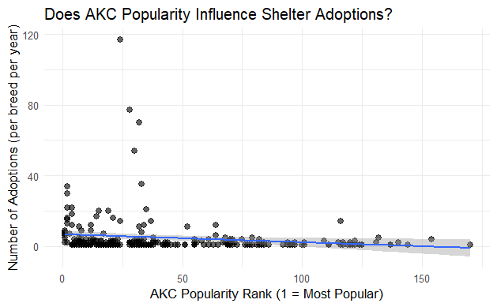

Figure 2a – Turnaround Stats
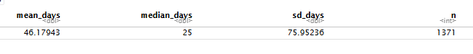
Figure 2b – Adoption Turnaround Histogram
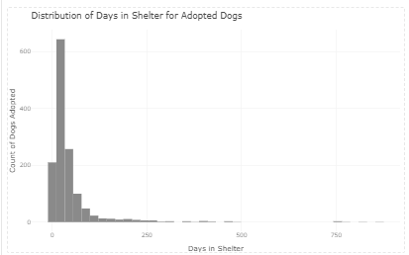
Figure 2c – Model
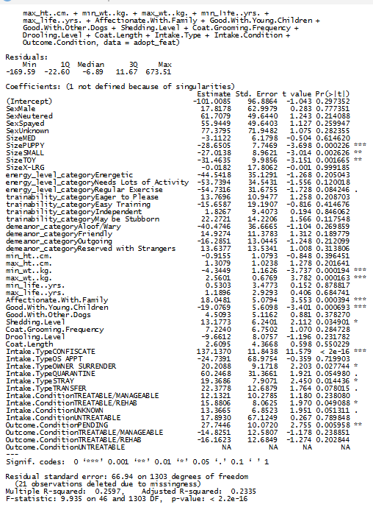
Figure 3a
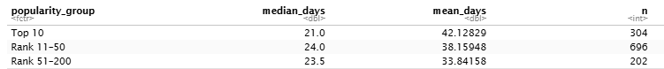

Figure 3b
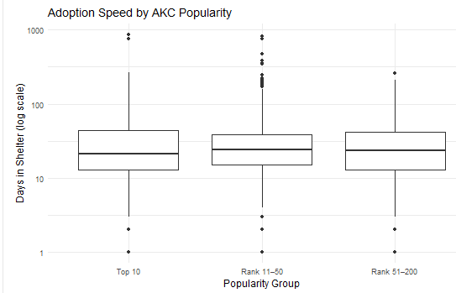

Figure 3c
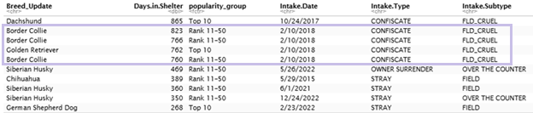

Figure 4a
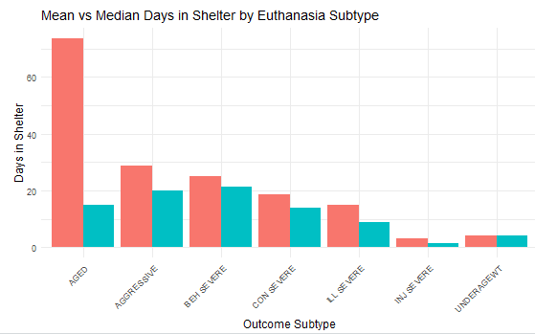

Figure 4b
